**User Story-1:**  
As a user, I want to know my delivery schedule time against my purchase order date.

Steps:

**Login to PMMS Application Inward Module Add Gate Entry**

**Add Vehicle Inspection**

New Fields Required Inward – “**Gate Entry**” – “**Vehicle Inspection**”:

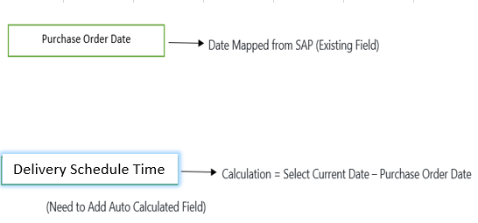

**Same Fields for Vehicle Inspection and Material inspection**

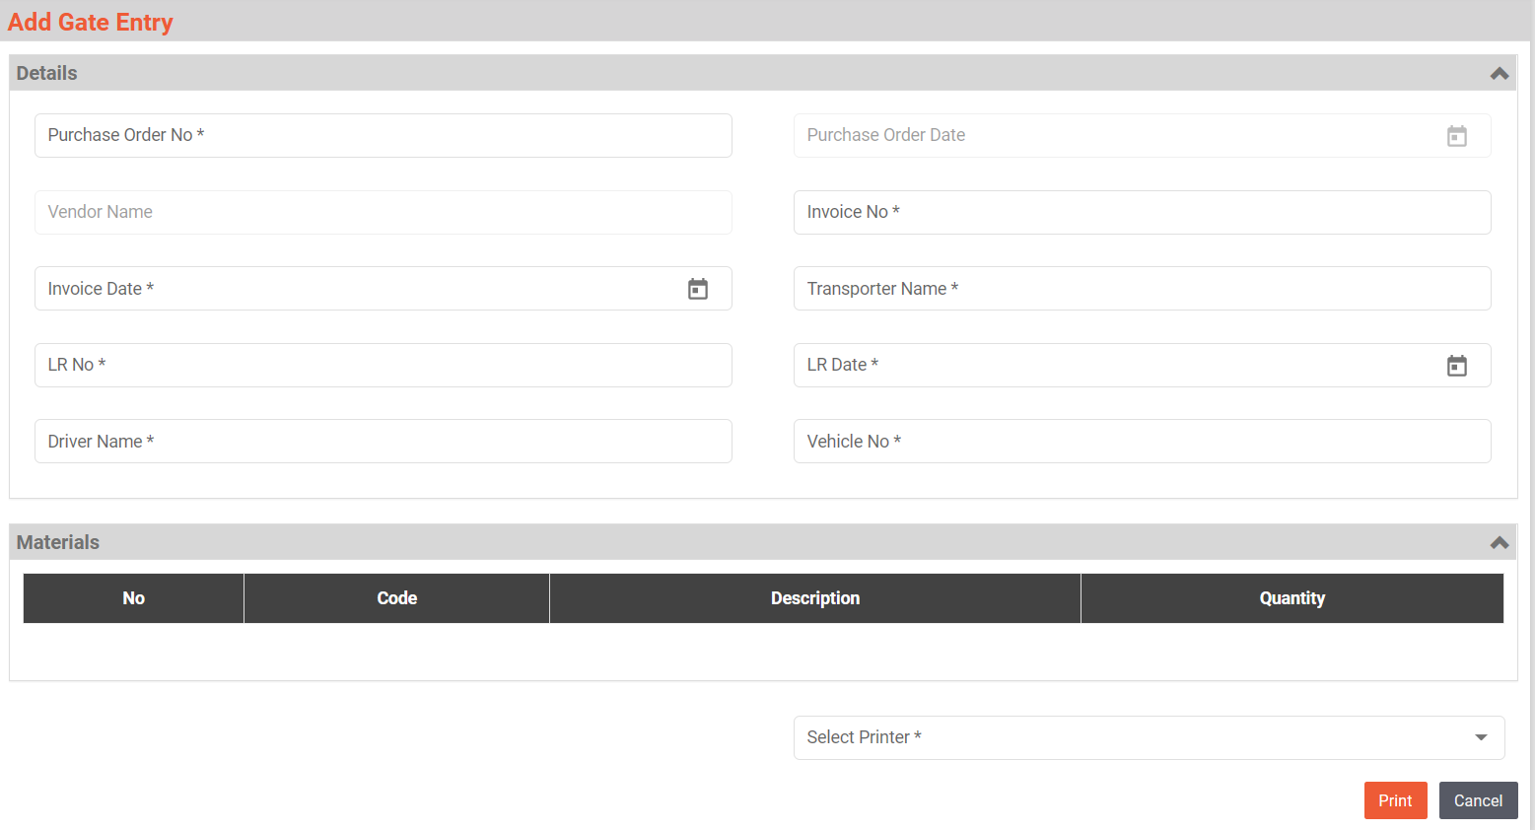

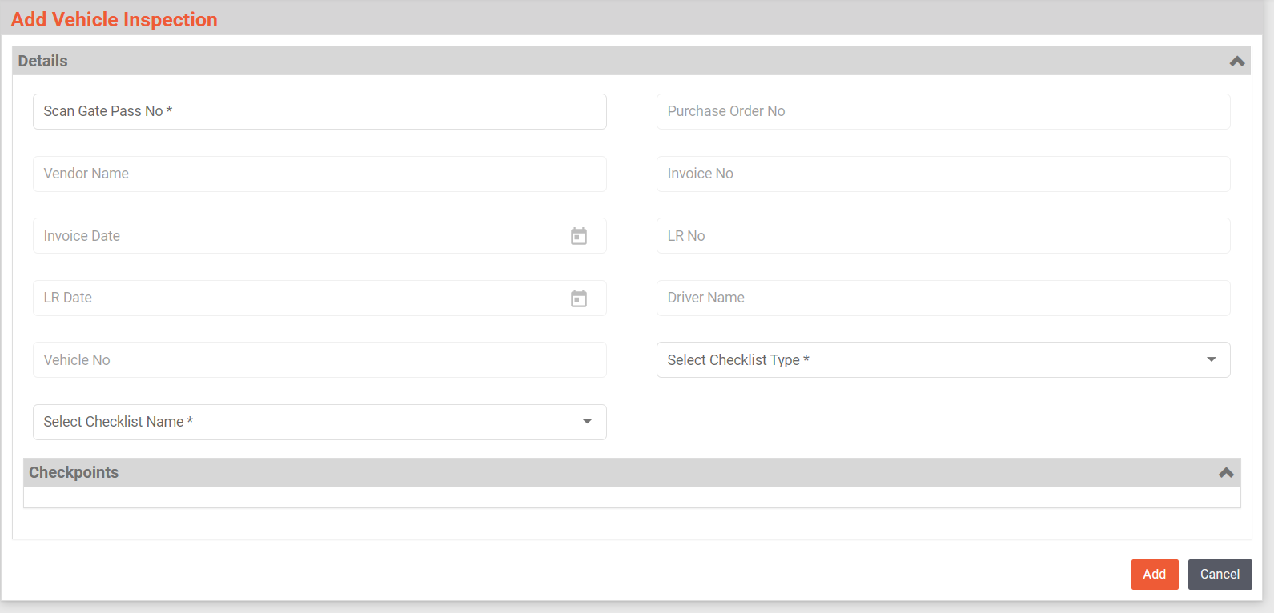

Note: Delivery Schedule time in No. of Days need to be displayed on Gate Entry and Vehicle Inspection UI “**Grid View**”.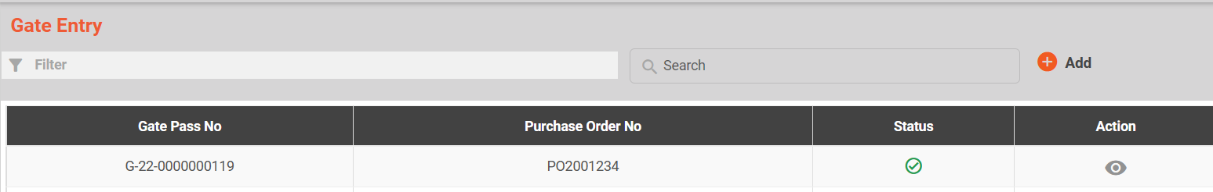

**User Story - 2**:  
As a user, I want to know my Expiry and Retest date Status in number of days.

**Steps:**

Login to PMMS Application Inward Module Add Material Inspection

**New Fields Required**:

1. Remaining Days Left (Against Expiry Date).

Formula: **=Exp Date Field-Today()**

1. Status (Against Expiry Date):

Formula: =**IF(Remaining Days Left Field<0,"Expired",IF(Remaining Days Left Field<30,"Expiring Soon", "Active"))**

1. Remaining Days Left: (Against Retest Date)

Formula: **=Retest Date Field-Today()**

1. Status: (Against Retest Date)

Formula**: IF(Remaining Days Left Field<0,"Retest Date was Passed", IF(Remaining Days Left Field<30,"Retest Date is Coming Soon", "Active"))**

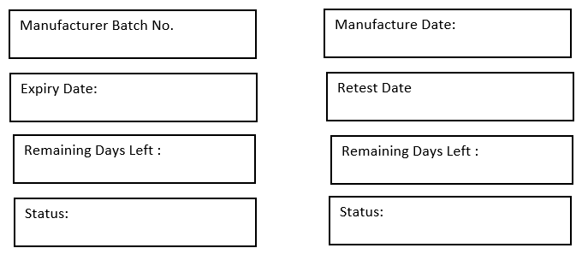

**Note: Status Colour –**

1. Active – Green, Expired.
2. Expired / Retest Date Passed – Red.
3. Expiring Soon / Retest Date Coming Soon – Yellow.

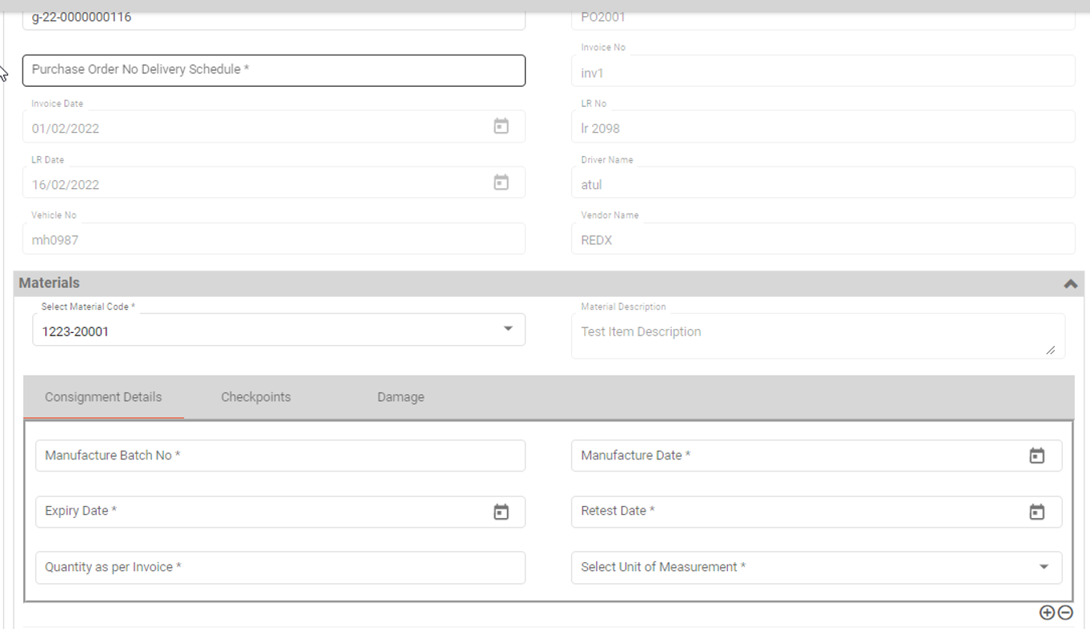

3. **User Story - 3:**  
As a user, I want to know my Cubicle Status. i.e., Cleaned, In-Process, Uncleaned.

**Steps:**

Login to PMMS Application Dispensing/Sampling Cubicle Assignment

Add Cubicle Assignment Select Cubicle ID  **Cubicle Status (Not in Use, Cleaned, In-Process, Uncleaned) (Automatic).**

**Mapping From:**

**CASE-1** (Status Change – **“Cleaned”**):

1. Dispensing/Sampling ---- Cubicle cleaning --- “**End**” button.

**Case -2** (Status Change – **“In-Process”**)

1. Dispensing/Sampling ---- Line Clearance “**Approved**” button.

**Case -3** (Status Change – **“Uncleaned”**):

1. Dispensing/Sampling ---- Stage Out “**Complete**” button.

**Case -4** (Status Change – **“Not in Use”**)

1. The cubicle is first time assigned.

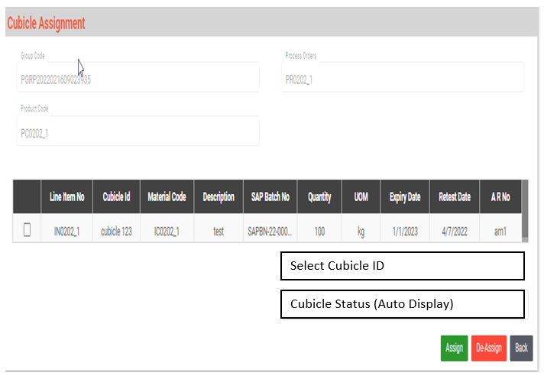

**UI Screens to Display “Cubicle Status”:**

1. **Cubicle Cleaning** -------------Scan Cubicle Barcode ----------- Cubicle Status **Mapping from Cubicle Assignment (Cubicle Status)**

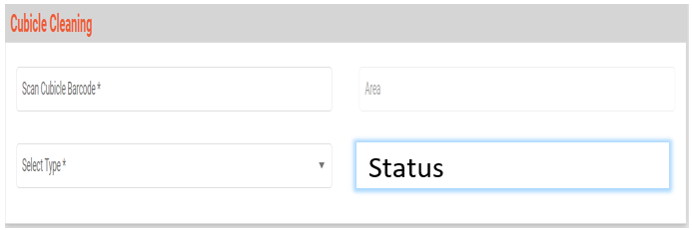

**Status to display:**

1. Not in Use.
2. Uncleaned
3. Cleaned.
4. **Line Clearance** --------- Scan Cubicle Barcode -------- Status **Mapping from Cubicle Assignment (Cubicle Status)**

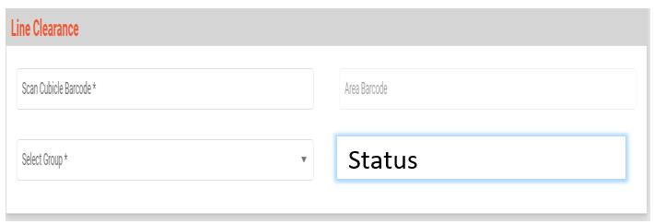

**Status to display:**

1. Cleaned.
2. Uncleaned.
3. Not in use.

**User Story - 4:**  
As a user, I want to know my Equipment Status. i.e., Cleaned, In-Process, Uncleaned.

**Steps:**

Login to PMMS Application Dispensing/Sampling Equipment Assignment

Add Equipment Assignment Select Equipment ID **Equipment Status (Not in Use, Cleaned, In-Process, Uncleaned) (Automatic).**

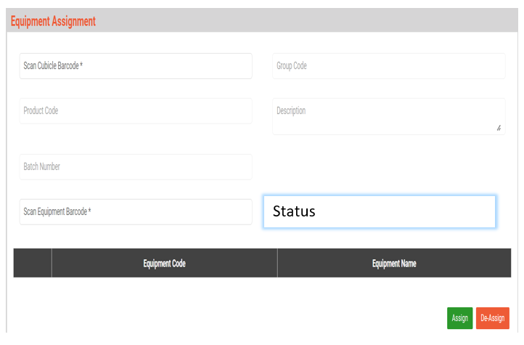

**Mapping From:**

**Case-1** (Status Change – **“Cleaned”**):

1. Dispensing/Sampling ---- Equipment cleaning --- “**End**” button.

**Case -2** (Status Change – **“In-Process”**)

1. Dispensing/Sampling ---- Line Clearance “**Approved**” button.

**Case -3** (Status Change – **“Uncleaned”**):

1. Dispensing/Sampling ---- Stage Out “**Complete**” button.

**Case -4** (Status Change – **“Not in Use”**)

1. The cubicle is first time assigned.

**UI Screens to Display “Cubicle Status”:**

1. Equipment Cleaning -------------Scan Equipment Barcode ------------ Equipment Status **Mapping from Equipment Assignment (Equipment Status)**

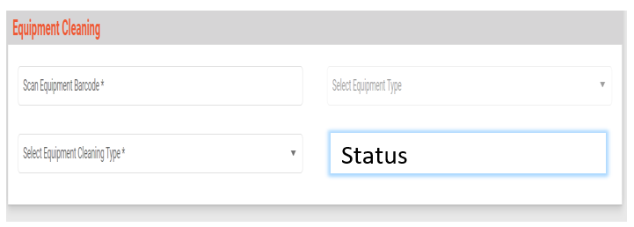

**Status to display:**

1. Not in Use.
2. Uncleaned
3. Cleaned.

**User Story - 4: Material Label Printing:**  
Current sequence flow for label printing range has been followed.

1. User should print all labels at once. No extra fields added for GRN No. Label Printing range.
2. QA person has authorization for material label printing range selection.

Cubicle/Equipment Not in Use:

1. New cubicle/Equipment First Time listed in Masters – “Not in Use”.
2. New cubicle/Equipment assigning for process activity “Cubicle/Equipment” – Before Assigned “Not in Use”, -- After Assigned – Uncleaned.
3. After Cleaning – Cubicle/Equipment not used in process for more than 3 days – Status – “Not in Use”.
4. After Stage out Complete – Cubicle/Equipment Status – “Uncleaned”.